**Class: TE AIML Academic Year: 2024-2025**

**Name: Rutuparna Kolte**

**Roll no.: 122A9042**

**Experiment – 7**

**Designing a two network configuration and updating the routing table of a**

**Router for a given topology (Static Routing )**

**_____________________________________________________________________**

**Aim**

To design a two network configuration and updating the routing table of a router for a given topology (Static Routing).

**Objectives**

1. Studying and implementing static routing.
2. Connecting two different networks, configuring the interfaces and updating routing table of given router for the given topology.

**Procedure**

**Design following network scenarios:**

**Scenario 1: Network with 1 Router**

1. Start packet tracer and design the network as given in Figure 1.
2. Configure the router and end devices as described in section below.
3. Test the configuration either by using a ping command or by sending simple PDUs.

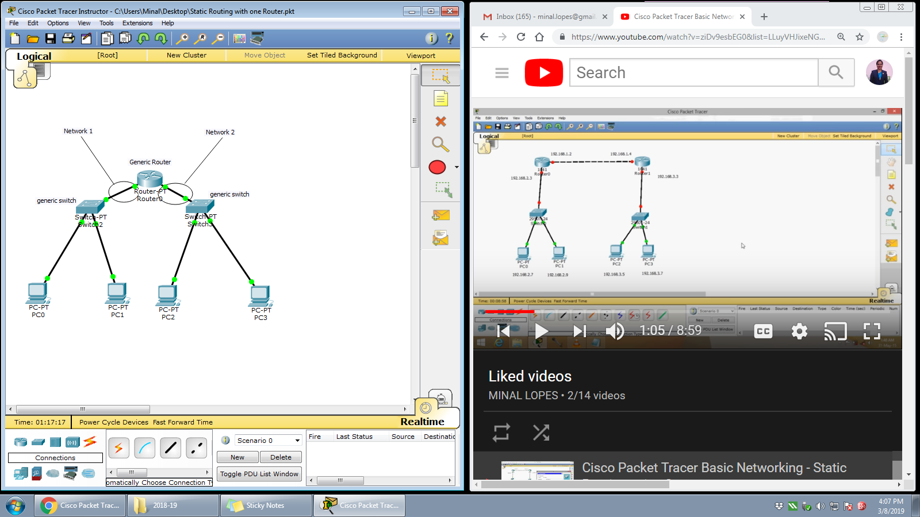

Figure 1

**Router Configuration:**

1. Reboot Router 0 by powering OFF and ON under the physical tab.
2. Router performs the Power ON Self-Test (POST).
3. Click on ‘Config’ tab and then choose one of the interface for configuration. Provide appropriate IP address and subnet mask.
4. Proceed similarly for all other interfaces in use.
5. To update the routing table of ‘Router 0’ follow these steps,
   1. Identify magnifying glass icon available at the vertical right pane of the packet tracer. Click the magnifying glass on to Router 0 and select the routing table from the drop down list. A routing table for Router 0 will be displayed having 2 entries typed as C (connected) with next hop field blank.
   2. The routing table is to be updated with the next hop entry, so that the Simple PDU could be send on to the other network. Provide following entries in the routing table: Network Address, Subnet mask, Next Hop.
6. Configure all the end devices by providing them IP address, subnet mask and the default gateway address.
7. Test your network by sending simple PDU’s or pinging the computers from one network to other network.
8. Specify your network’s configuration details in table given below.

|  |  |  |
| --- | --- | --- |
| **Sr. No.** | **Network Device** | **Configuration (IP address, subnet mask, default gateway addr)** |
| 1 | Generic Router 0 | Interface: FastEthernet 0/0  IP address: 192.168.1.1  Subnet address:255.255.255.0 |
| Interface: FastEthernet 1/0  IP address:  Subnet address: |
| 2 | PC0 | IP Address:  Subnet address:  default gateway: |
| 3 | PC1 | IP Address:  Subnet address:  default gateway: |
| 4 | PC2 | IP Address:  Subnet address:  default gateway: |
| 5 | PC3 | IP Address:  Subnet address:  default gateway: |

**Scenario 2: Network with 2 Router**

1. Start packet tracer and design the network as given in Figure 2.
2. Configure the router and end devices as described.
3. Test the configuration either by using a ping command or by sending simple PDUs.

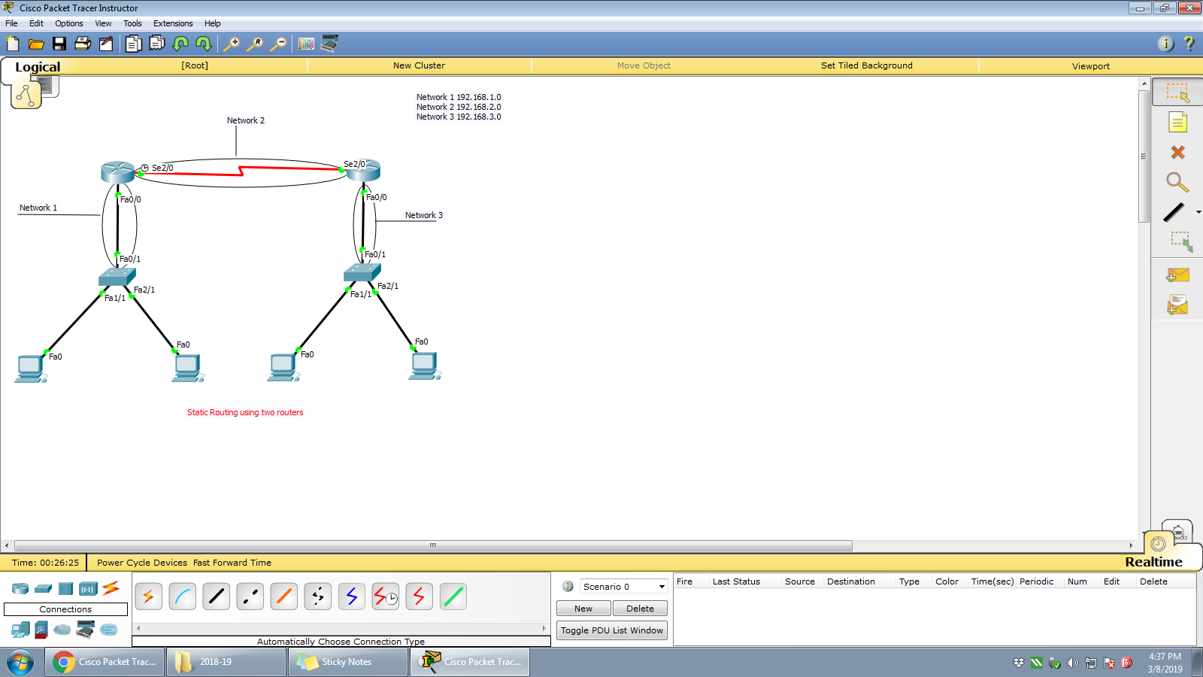

Figure 2

|  |  |  |
| --- | --- | --- |
| **Sr. No.** | **Network Device** | **Configuration (IP address, subnet mask, default gateway addr)** |
| 1 | Generic Router 0 | Interface:  IP address:  Subnet address: |
| Interface:  IP address:  Subnet address: |
| Static Routing Table  192.168.3.0/24 via 192.168.2.2 |
| 2 | Generic Router 1 | Interface:  IP address:  Subnet address: |
| Interface:  IP address:  Subnet address: |
| Static Routing Table |

Take screenshots for both the network scenarios showing successful PDU transmission from one network to other and attach as the output.

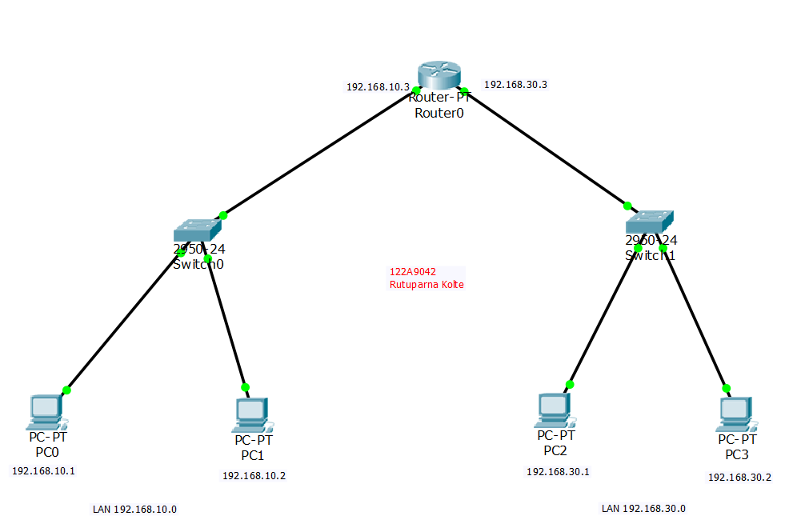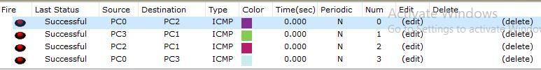

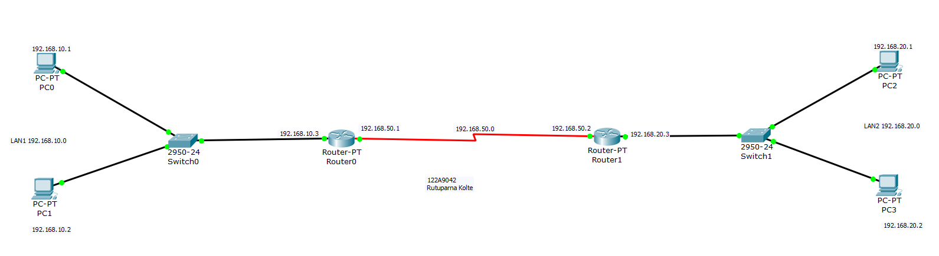

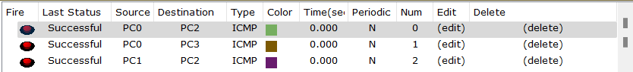

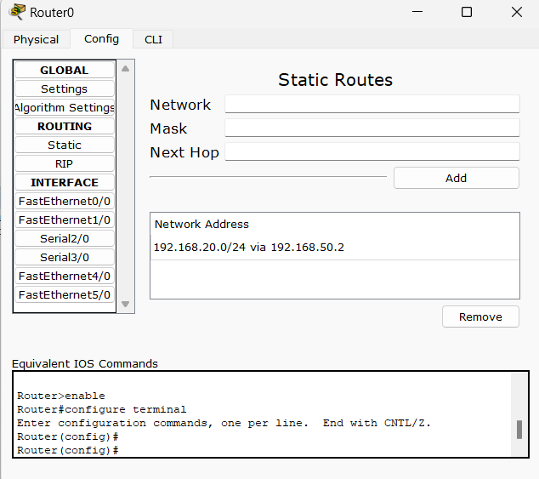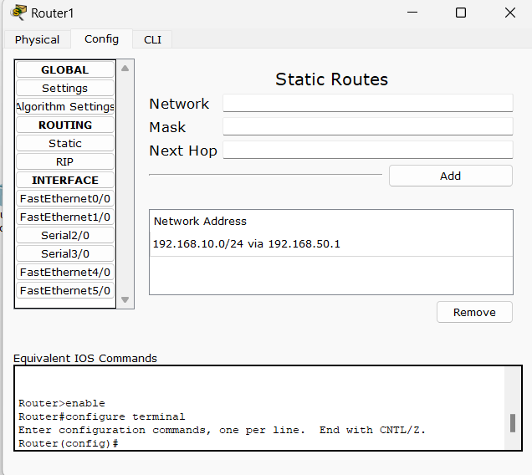

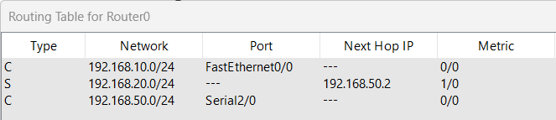

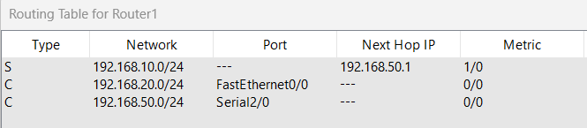

**Conclusion:**

In this experiment the routers interfaces and routing tables are configured statically and checked that simple PDU’s are transmitted from one network to another through routers. Thus we learned to design a simple network with routers using static routing.

**Post Experiment Exercise:**

Design a network with three routers to perform static routing. Draw the diagram (on paper) and indicate all the configurations required to perform static routing.



